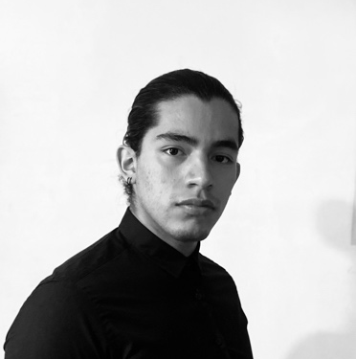

LANGUAGES
BENJAMÍN
AGUILAR LEÓN

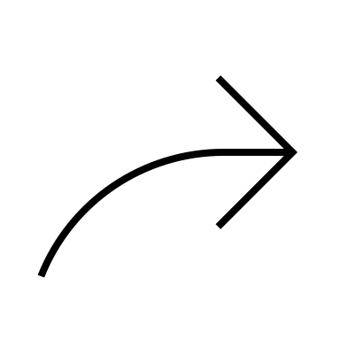






June 2021 – December 2022
CAD FOR MECHANICAL DESIGN IN FUSION 360 – Autodesk

January 2023 - In progress.
PROJECT MANAGMENT – Google Certification

CERTIFICATIONS
01/23 – To date
LEZMAN INNOVACIÓN | Monterrey, Nuevo León.
Project engineer.
- Design and manufacturing of pieces in the milling machine. Building of automation machines, assembly of control units, programation of PLC in CCW and TIA Portal.
- Develop of OE
- Installation of equipment in production lines and maintenance.

04/22 – 09/22
CIITEC | México, CDMX.
Social service developing advanced engineering machines for specific process.
- Design and building a vertical reactor for MOCVD processes, automating the process to be able to deposit alumina layers on different alloys.

08/19 – 08/21
MIRAMONTES | México, CDMX.
Appliance workshop assistant.
- Support and attention in the various areas of the store from repair, customer service, cash management and support to increase the customer satisfaction.

CCW
TIA PORTAL
RAPID PROGRAMATION
MICROCONTROLLERS /ELECTRONICS
PYTHON / C++ / HTML / ENSAMBLADOR

PNEUMATICS
MANUFACTURE
AUTOMATION /PLC
HARD SKILLS
SOFT SKILLS
Leadership: Skills for group management and interest in exercising the position of leader.
Motivation: Orientation to success in the objectives and professional orientation to the work group

Social Intelligence: It is easy for me to socialize with people have just met and adapt depending on the people and situation in which I find myself.
Autonomy: I can work without having to have someone constantly tell me what to do.

*Click on the button to view the projects
PERSONAL SUCCESS
- 3rd. place in Central American Karate.
- TEDx Youth Polanco Conference: “Hand in hand towards the future”.
WORK EXPERIENCE
B R I E F C A S E
- Design and building a vertical reactor for MOCVD processes, automating the process to be able to deposit alumina layers on different alloys.
- Developed an innovative system that allows the correlation of a three-dimensional model and a code printed on the skin to deposit ink on the extremities of the body.
- Design and implementation of low-cost myoelectric prostheses.
- Train and actively participate in the high school robotics team in the mini sumo and Lego category.
- Development of educational robotics and home care platforms.
- Development of various electronic and automation systems.
- Design and construction of a robotic arm controlled by MATLAB and Arduino using direct and inverse kinematics.

PROJECTS
INDUSTRIAL ROBOTICS ENGINEER
CONTACT
EAGLE
AUTOCAD

FUSIÓN 360

SOFTWARE
English – Advanced.

French – Basic.

Graduated from ESIME Azcapotzalco of the IPN. I specialize in 3D design with Fusion 360 and PCB design in Eagle.
I have a background in education, customer service, and have had the opportunity to speak at TEDx about the development of low-cost robotic prosthetics.
PROFILE
CDMX, Azcapotzalco.
BenjaminAleon@hotmail.com
55 8442 9802
/benjamin-al
Spanish – Native Advanced.

